**CS 487 DATA SECURITY**

**HOP06 – Deploy Storage Account**

12/28/2020 Developed by Mary Oh

Center for Information Assurance (CIAE) @City University of Seattle (CityU)

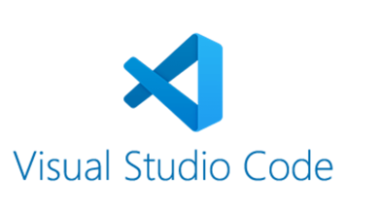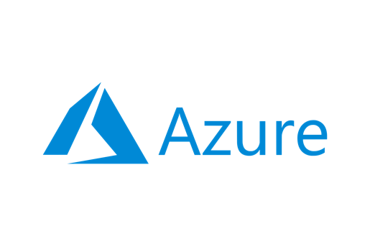

**Before You Start**

* Version numbers may not match with the most current version at the time of writing. If given the option to choose between stable release (long-term support) or most recent, please choose the stable release rather than beta-testing version.
* This tutorial targets Windows users and MacOS users.
* There might be subtle discrepancies along the steps. Please use your best judgement while going through this cookbook style tutorial to complete each step.
* For your working directory, use your course number. This tutorial may use a different course number as an example.
* The directory path shown in screenshots may be different from yours.
* If you are not sure what to do or confused with any steps:
  + Consult the resources listed below.
  + If you cannot solve the problem after a few tries, ask a TA for help.

**Learning Outcomes**

* Learn how to use Visual Studio Code to deploy Storage Account

**Resources**

* Microsoft Azure - [https://azure.microsoft.com/](https://azure.microsoft.com/en-us/overview/what-is-azure/?&ef_id=Cj0KCQiAlsv_BRDtARIsAHMGVSac9cd8I7htfl0EVYTYDUBxYJ7mEqQ6dB5bRem2ziaBp-j1Di4wui8aAivlEALw_wcB:G:s&OCID=AID2100131_SEM_Cj0KCQiAlsv_BRDtARIsAHMGVSac9cd8I7htfl0EVYTYDUBxYJ7mEqQ6dB5bRem2ziaBp-j1Di4wui8aAivlEALw_wcB:G:s&gclid=Cj0KCQiAlsv_BRDtARIsAHMGVSac9cd8I7htfl0EVYTYDUBxYJ7mEqQ6dB5bRem2ziaBp-j1Di4wui8aAivlEALw_wcB)
* Microsoft Documentation - <https://docs.microsoft.com/>

**What is Azure?**

Azure cloud platform is cloud services designed to help bring new solutions to life. You can build, run, and manage application across multiple clouds, on-premises, and at the edge, with the tools and frameworks of your choice.

**What is Storage Account?**

Azure storage account contains all of your Azure Storage data objects such as blobs, files, queues, tables, and disks. This provides a unique namespace for your data that is accessible from anywhere in the world over the HTTP or HTTPS. Data in your storage account is durable and highly available, secure and massively scalable.

**Create ARM template**

1. Open Visual Studio Code and create a new file named storageaccount.json.
2. Enter `arm!` to create a template scoped for an Azure resource group deployment

1. Add resources to your deployment template. Type `storage` on the resources block and select the arm-storage.

1. Add template parameters. Type `”new-parameter”` in the parameter block.

1. Update the name of parameter and description.

1. Azure storage account names have a minimum length of 3 characters and a maximum of 24. Add both `minLength` and `maxLength` to the parameter.

1. On storage resource, update the name property to use the parameter. Enter the following and select the parameter “storageAccountName”.

1. Make sure to save all changes made.

**Create a parameter file**

1. Create a parameter file. Right-click on the template in the code editor and select `Select/Create Parameter File’.

1. Select `New` > `All Parameters` > Enter storageaccount.parameters.json as the name and select the location for the parameter file > Save.

1. On the parameters file, update the “storageAccountName” value to your name and save.

1. Make sure to save all changes made.

**Deploy template to Azure**

1. Open the integrated Visual Studio Code terminal using ctrl + ` key.
2. Sign in using your Azure account information. This will open up a new window to sign in.



1. Create resource group. Enter the following command.

1. Deploy the template. Type the following command. Ensure you are in the correct directory where the file is saved.

1. Verify that your deployment was successful. Open your browser and head to your Azure portal. Select Resource Groups.
2. Locate and open the resource group arm-vscode. Verify that the storage account is successfully deployed.

1. To avoid incurring any unnecessary fees, clean up resources. Type the following command in your terminal and enter y.



1. Verify if successful. Head to your Azure in your web browser and refresh. The arm-vscode resource group should not be showing.

**Questions you can answer for submissions:**

1. **Knowledge:** Why is Storage Account important?
2. **Knowledge:** What is Storage Account? Provide an analogy to understand it better.
3. **Application:** When to use Storage Account? Why?

**Push your work to GitHub**

1. Open the integrated Visual Studio Code terminal using ctrl + ` key. Make sure you are in the right path.
2. Type the following command:

git add . (to copy all changes you have made)

git commit -m “Submission for Module 6 - YourGitHubUsername” (To add a message to your submission)

git push origin master (to upload your work to Github)